TEST
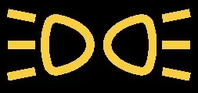

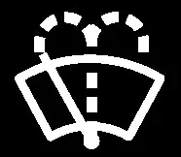
RACE

SLOWNESS


8 6 4 2
RACE
7 5 3 1
TEST

LIGHTS
WIPERS
WASH
RACE
DIPS
WIPE SLOWNESS
FAN
TEST

